The Malamander – Fletcher
Poetry
He slaps the sand with twisted tentacles;
Close to towns in dangerous lands,
Ring’d with his jet black world, he rules.
The desperate creatures beneath him hide;
He observes from his hidden lair,
And like a torpedo, he strikes.
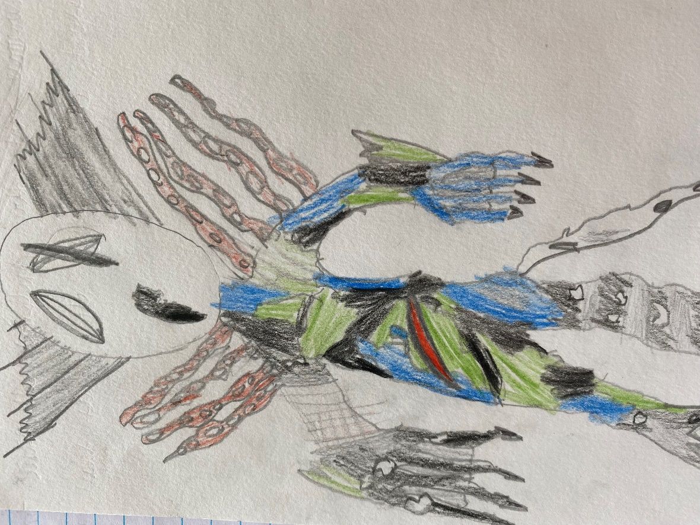

Story writing
‘What’s wrong?’ I say, but Oscar puts his finger to my lips and he drags me behind a rock.
‘D-d-d-did you hear that?’ stuttered Oscar, as his entire body trembles.
‘A bird,’ I say in a sarcastic tone.
Unamused with me, Oscar hisses ‘There it is again!’
I stick my head up but I hear nothing. I look up again but all I see is darkness and reflecting moonlight. But then…
There’s an uninviting howl coming from the pipe, a howl so nightmarish it would send a shiver down even the bravest of people’s spines. We instantly stare into each other’s eyes, it looks like blood has drained out of our faces. Without thinking twice, we turn our torches on and point them at the pipe. Then, the noise came again but this time it was more like a shriek. The only difference was it was louder, so we instantly turn off our torches. There was something in the pipe.
The bangs quietened down but something was still moving forward. Suddenly, there was an eye in the gap. It illuminates with stolen moonlight. Its pupil shrunk as it examined the area and then it widened again back to an endless pit of darkness. It started to move forward. Without warning, it stopped. Its tongue crept out, feeling its surroundings.

