The Malamander – Isaac
Poetry
It lurks in the shadows with bloodstained claws;
Ready to kill with monstrous jaws,
With the sounds of a dying whale, he roars.
Venomous teeth and wide, scaly gills;
He observes his domain with much disgust,
And like a torpedo, he kills.

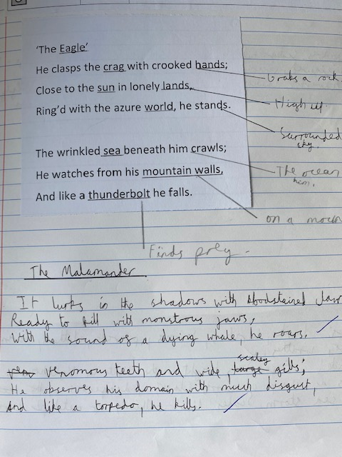

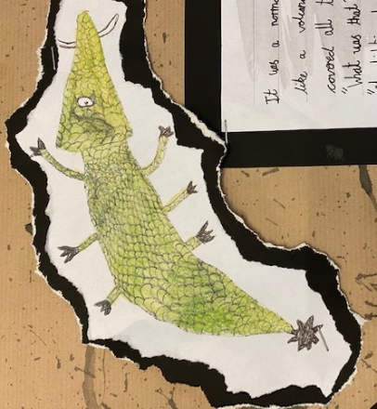

Story writing
‘How much longer?’ I sighed, sinking into an armchair.
‘You’ve asked that about five hundred times,’ Patricia muttered, examining her map.
‘Where are we even going?’
‘Honestly,’ she said shakily, looking up from her map, ‘I don’t know.’
And that was that. She looked back at her map, her shoulders slumped more than usual. ‘That explains a lot,’ I thought to myself. Suddenlty, the lights flickered on and off. ‘P-please tell me you saw th-that?’ I stuttered.
‘Saw what?’
As if answering her question, the lights vanished. ‘AAAAHHH!’
‘Let’s go find Bill,’ I gulped, ‘he’ll know what to do.’
‘Agreed.’
We set off- scared to the bone – huddling close to each other. Then, some great force caused the boat to shudder, catching me and Patricia off guard, making us plummet to the ground.
The rocking continued, making my stomach drunkenly rattle and my fear levels rise critically. We clasped the railing and hoisted ourselves up. I felt mildly safe until I saw the floorboards wincing and buckling until they burst open and a huge tentacle sprang up out of the hole. Salt water erupted out of the floor, spewing unwanted liquid over us. Frozen in terror, we watched the ‘something’ blindly reach out for us and for a split second I thought it had us in his grasp. We watched him recoil back into the water and we let out a long-held sigh. Unfortunately for us, we had to scream some more as a tentacle swiped through the side of the ship.
A mix of adrenaline and profound terror overcame us and we desperately began to run for our lives. Every second we sprinted, a tentacle would pierce the place where our heads had been a second before. We ducked and swerved and leaped – closely avoiding his fatal attempts. Our raspy breathing paired rhythmically to our rapid heartbeats. And that’s when we ran directly into the hindrance known as ‘Dead End’.
Our legs widened in horror at the sight of this barricade. Hesitantly, we turned to face the behemoth. Bile rose up my throat at the sight of him. His singular, vermillion eye glared at us. His scales rippled perfectly to the tide of the sea and his magenta tentacles flowed behind him. Its spines sprang up layers of needle-like teeth. Ever so slowly, it slithered towards us. A thousand images of me lying in blood flooded my brain and I knew there was no escape. Reluctantly, I accepted death.
Or did I? My eyes scanned the room for something, anything. Finally, they rested upon something that could potentially save us – the fire alarm! I rolled through the monster’s legs and slammed my fist to the ground, its monstrous hands clamped on his ears. I grabbed Patricia’s wrist and pulled her out of the action – we had to get to Bill!
What was that? Where did it come from? A million more questions flooded my head but most importantly – is it still after us?

