The Malamander – Eva
Poetry
He stalks in moonlight with silent intentions;
Scales steal the fraction of hope, light and warmth in the night,
Surrounded by his devilish world, he snakes.
An overgrown power within him twitches;
He observes unnoticed, unknown.
And like an army, he finally strikes.
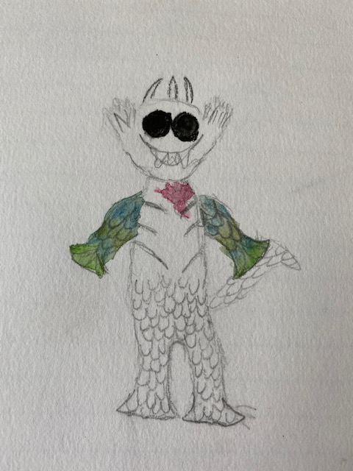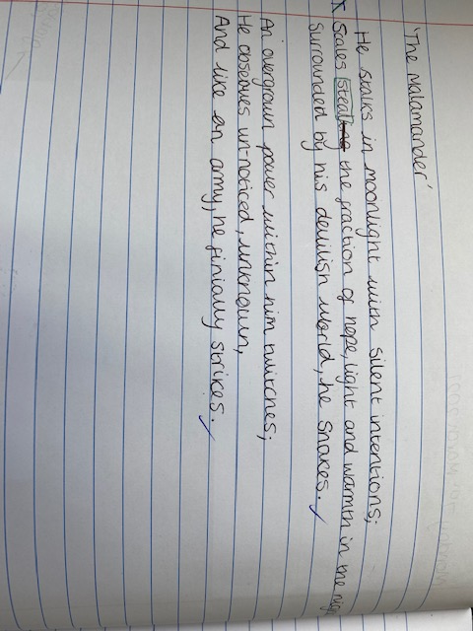

Story writing
Silence. Nothing could be heard. Just silence. Every few minutes a car would drive past breaking the tense air, making the sound of waves washing up the shore on a beach. That night nothing was right, no one was out. Darkness fell quicker and only the slightest breeze snaked its way through the streets, looking for someone, something.
‘Vi, we should go home now,’ I looked at her with a serious expression.
‘When did you become so adult-like?’ she asked suspiciously.
‘That’s not fair! I’m still Herbert, it’s just I think we should go home now.’ I stared at her blankly for a few seconds then turned to look sharply at the floor. ‘Well I’m not going home becau-‘
‘Shh!’ I spat sharply.
‘Why are you staring at a drain?’
‘Shh shh shh! There is something down there, I swear!’
A slow scraping noise made its way closer and closer to the top of the drain. Then there was a sudden slap from surprisingly near to us. My eyes widened, I could not move. I thought that my heart would stop beating any second now. Violet’s mouth was gaping wide open and she started to fiddle intensely with her jeans. The scraping noise came again, this time echoing through the sewer, bouncing off the walls, making its way up to the surface. As soon as it hit our ears, we almost fell to the ground. It was horrible, not just horrible, but nightmarish. The only type of sound that wouldn’t be in horror films, it was that hideous. It stopped suddenly. Something glimmered down there. A coin? A scale?
Vi let out an unexpected shriek, almost as deafening as the noise down there. ‘What?’ I gasped.
‘A tentacle!’ It was true, a tentacle weaved drunkenly through the bars of the drain, attempting to wrap itself around Vi’s leg. We needed to run. But before I could say anything, an eye the size of a tick-tick-ticking clock made its way up to the bars and stared at us. I assume it had two but at the moment we can only see one blood-shot red eye. It blinks. The following events happened so quickly that the monster was merely a blur across my vision.
I didn’t know how to save her, when to save her, I didn’t know why the monster was taking her. All I knew was that my best friend was being dragged down, down into the sewer. Everything turned to slow motion. The look on her face was unbearable. She reached out, shouting for me, until, she was gone. One last glimpse of the creature’s evil glance and it was too late; she was truly gone.
I now realise – it was the Malamander.
