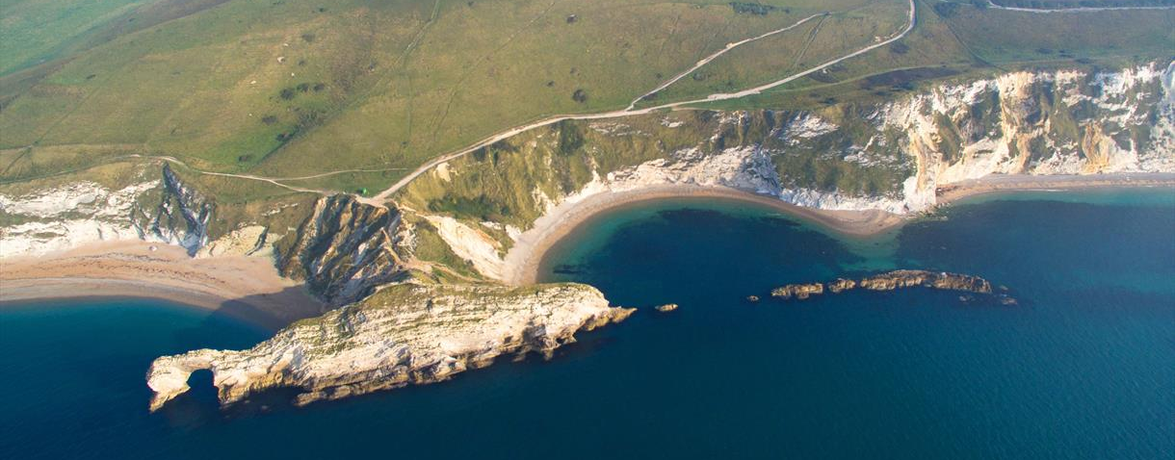
A Boathouse in 2120

I flew over the Jurassic Coast looking down at Durdle Door.
Nearly there, my new home!
I was filled with anticipation. This really felt like I was coming home as generations of my family have had houses here.

Climbing out of my drone taxi, I caught the first glimpse of my brand new house, designed like a boat because it hangs over the water and the sea levels are still rising. It had carbon fibre walls with squeaky clean glass windows. Everything was polished to the point it looked like mirrors and a face recognition door opened when I stepped near the entrance.

Gliding towards me, a robot butler took my coat and suitcases and showed me around my new home. The main room was minimalist and loaded with state of the art technology. A clever hologram machine sat on a fibre glass table and a fridge, that ordered food when running low, rested against the other wall. The boathouse had everything I needed but it was all cleverly hidden away, ready to come out at the touch of a button! The voice activated lighting system ran around the whole vessel. Although I had windows for natural light, my favourite element was the ability to project any image/scenery onto them as a view.

Coming in, in silence, the butler having unpacked my things, handed me my photos and books. In with my books were my recently inherited family diaries which I hadn’t had a chance to read yet.

I wandered to my bedroom and sat on my bed pod, it felt very comfortable especially as it keeps you the ideal temperature for a perfect night sleep.
Feeling tired and nostalgic, I gently opened the first book at the half way point, I noticed the elegant

It read...

Monday 21st
January 1918

Dear diary,

Today was not unusual, in all it was quite normal. Citizens were gathering upon our streets holding notices quoting that women should have the equal vote. I most certainly acknowledge these dashing young ladies and I applaud the effort of our communities.....

Lilian Lomas
24 years

All kinds of thought waves rushed through my head; so that’s how women got the vote, it all makes perfect sense, the Suffragettes were so brave.

Wanting to know more about my ancestors, I grabbed another diary and read another extract. This time it was from 2020 and written by my Great Nan. Strangely it was written in coloured pens!
This one read...

Monday 23rd
March 2020

Dear diary,

Today was not a normal day, as schools around the country closed on Friday due to the Coronavirus. Now we need to stay 2 metres away from people outside our household and some people are wearing facemasks if they go out in public. Restaurants, shops and leisure centres all closed a few weeks ago and we are not meant to leave our house unless it is for exercise, food shopping, helping vulnerable people or to work if you can’t work from home.

It is very strange doing school work at home and I miss my friends but at least I can talk to them on FaceTime.....

Leah Murphy
11 years

More thoughts filled my mind and I started to wonder if Leah’s diary extract was similar to many other children’s back then. It also explains where the tradition of wearing face masks every Easter Saturday came from.

Being in my twenties, I have my whole life ahead of me here so it will be my turn to write in the diary – I wonder who will read it in years to come.....

