At seven when I go to bed
I find such pictures in my head
Pastel rainbows in the sky
Enchanted deer trotting by
Vibrant bushes, candyfloss clouds
The magical castle standing proud
Clear still water sparkling in the day
Gentle sunlight-you want to lose your way
I find so clearly in my head
At seven when I go to bed

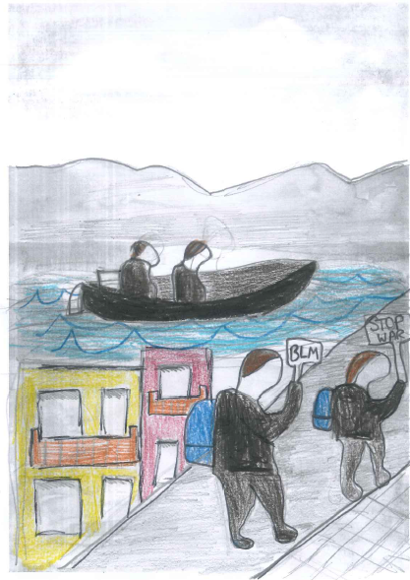
At seven when I wake again
The magic land I seek in vain
A national pandemic pausing our lives
But protests a carry on-we need to thrive
Ice bergs are melting, there’s no planet B
There’s plastic in the ocean because of people like you and me
People are escaping-they will feel alone
They have no place-not even a home
I seek the magic land in vain
At seven when I wake again.

By Phoebe McColl Age 11

