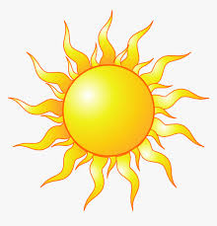 Sun poem

I yawned as loud as a lion’s roar,
I stretched my golden gleaming rays,
I peeked from behind a cushioned cotton cloud,
I glimpsed children playing like a shoal of dolphins,
I covered the earth to the brim with light,
I appreciated my wonderful journey,
I lowered my sleepy self slowly,
I settled my fatigued fuel,
I welcomed the oncoming orbiting moon.

