The Green Door
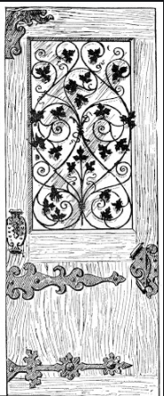

Finley Noble
Year 5
West Park Primary School
There one stood: a boy, whose soul was no longer there. Motionless and trembling with fear, his eyes were transfixed on the emerald-green door. Lifeless tendrils strangled that door. His heart skipped a beat as he slowly paced towards the teal frame. A shaking outstretched hand sluggishly reached for the oily handle. Then one found himself exquisitely glad, as he turned it with ease.
The fern-green door inevitably creaked open. He opened his eyes and the rustle of nature filled his ears. The reassuring aroma of passion flowers filled his heart with the early chapters of his life. Sapphire parrots soared through the jade canopy as he meandered down the corridor of green. Brightly- coloured creepers like part streamers dangled down – he pushed them aside like a curtain. Pausing, his eyes transfixed. As if in a trance, he inquisitively escorted himself towards it.
A swarm of amethyst butterflied pirouetted on the tapestry of fresh air. He gazed at the violet insects as they flaunted on wisps of crisp air. The bouquet of sweet alluvial exploded into the atmosphere. He paced on as insects delicately danced on the whispers of gentle breeze. He eyes were drawn upwards amongst the leaves – branches were spread and gnarled like a prehistoric beast. Coiled and spiralised, tortile and wound, lianas tightly strangled one another as they raced for life up the myriad of tantalising trunks. Roosts grasped at his ankles like bony fingers as dead orchids tore at his hip leaving a serrated gash in his flesh – blood swelled under his skin. Corpse-like he ventured on into the unknown.

