The Green Door
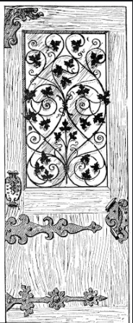

Grace Wright
Year 6
West Park Primary School

Reassuring, welcoming voices drew him in. He had a gust of positive emotion as he approached the mysterious green door. He heard the sound of chirping birds, who began to sing a graceful song; he knew he was not dreaming. His pale hand was outstretched, grasping on to the golden handle. Nostalgically, he remembered when he was young; he was joyful and glad in this mysterious place. After twisting the handle, with excitement, his temptation to go on grew higher. He had a sense of lightness running through his body. He pushed the door open to reveal the wonders of this spectacular place.
In that very moment, he forgot the auburn leaves collapsing onto the bleak road; he forgot the piles of paperwork on his desk, and the quarrel he recently had with a companion. Delirium engulfed him entirely. By opening the door, he opened the pages of the rainforest; the viridescent leaves illuminated the memories of his childhood. His mind created an image of his friends; Lila, Max and Con. He missed Lila’s comforting words; Max’s laughter and even Con’s screeching.
The damp, earthy foliage and stifling humid air trapped him like a prisoner locked in his cell but he ventured on. He could create an image of a festival of exotic colours whilst gazing at the tropical birds as they sang their magical chorus. The gleaming water cascaded through the hues of emerald and lime; fern moss was hugging onto the jagged rocks as they perched motionless. He could still smell the russet, crimson fire from when the plane crashed, but the fragrances and scents of the floras and fresh, serrated leaves overtook it quickly. He could smell the misty air that travelled through the forest and the damp, earthy foliage that rustled underneath him.
The lavender’s essence; the hellaconia flower’s fragrance and the rhododendron’s scent gave him a reassuring, warm feeling- almost like his own home. Viridescent vines coiled around the great Kapok tree like a snake catching its prey. Dancing in the air, the tropical birds fluttered their wings and sang a harmonious tune. Fred could taste his nostalgic past; it sent butterflies to his stomach as he let out a screech of agony.
The clouds were crying; he knew it was time to go. He peered at the forest’s giants whilst producing a glistening smile. He stared at the rainbow- like parrots and listened to the immense waterfall trickling down the rough rocks, which were covered in rich green moss and ivory. The tangerine-like orang-utans were swinging from branch to branch-their infants clutching onto their fur. Fred was overjoyed! Ecstatic and joyful, grateful and pleased, he twisted the golden handle- his memories restored once again.

