The Green Door
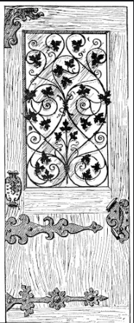

Marley Smith
Year 6
West Park Primary School

Soon enough, he was standing there, motionless and as still as a statue; face-to face with the olive green door. Emotions of pure excitement and enlightenment were pouring out of his ears and nose. After a while, he reached out a trembling hand – his whole body overrun with joy. He slowly turned the knob of the old, wooden door.
The door opened to every shade of green. A dense canopy of dew-soaked leaves dappled the crumbling ground. He slowly stepped forward, speechless. He was inches from the frame of the door. Something deep inside of him warned him not to feel secure, as a less distance voice told him to go on, so he did.
An extensive slap of stench struck him. Orchids, moss, dew, all smells surrounded him. Then he realised where he was: he was in a beautiful forest! The evergreen labyrinth made his childhood flash before his eyes. He stopped for a moment, silhouetted against the rising skyline. As the sky rose, so did the enchanting animals. Morning had come. An outcry of macaws echoed from the canopy. They were like flying rainbow creatures- was there every colour imaginable on those beautiful birds?
A low moan came from the mossy clearing. It was an intimidating jaguar. Its sharp, onyx eyes didn’t miss him- the chase was on. He darted his way through the trees, the jaguar following him right behind him. “This race won’t last long,” he thought. At last, her turned a corner and lost it and was yet again faced with the olive green door.
After throwing away some apprehensive thoughts, he took one last deep breath of the tepid, tropical air. A swirl of all emotions swelled through his body. He gathered his courage, still half traumatised, and turned the knob of the green door. The door that was like pure magic and the door that brought him to his favourite place in the world. He opened the door, the magnificent forest behind him, waiting for the next adventure…

