The Green Door
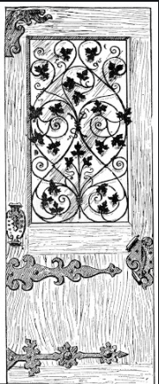

Sophia Brooks
Year 6
West Park Primary School
Out of the corner of his eye, he caught a glimpse of what seems like an ancient, decayed fern-coloured door. At that moment, flashbacks started to soar; he could see himself as a child reaching for the door, but he hesitated and ran away. Would he now reveal the secrets that lay beyond? He quietly mumbled under his breath, ‘Now is the time.’ Adrenaline started to build, every muscle and limb were tingling, giving one a sense of lightness. Building up to a pace, he started to push aside branches until he got to an exquisitely built hallway of trees. It was just him, the door and no way back!
Despite his fear, he burst through the enticing- drawing you in – door, his eyes were filled with excitement; a sense of exhilaration. Wide-eyed and fixated, cautious and intrigued, he stood there in total awe; the song birds sung and the orchids bloomed in response. He gradually placed one foot in front of the other trying to take in every aspect.
There were trees beyond trees and plants beyond plants; the horizon was a green smudge. High within the canopy, flowers dahlia and teal were looping the trees paranormally. It was not until he looked closer that he saw the tapestry and it was not until he was very close that he saw it was made up of a thousand different colours; lime and emerald; moss and jade and a deep dark almost black-green that made him think of sunken ships.
Unable to resist temptation, he moved on. A predator, that was painted black and yellow, danced between the rubber trees – calling him forward, inviting him to play hide and seek. One did not decide to run, but instead to creep unnoticed towards the intriguing carnivore. Why? One does not know. One can just sense fear.
After chasing the predator for quite some time, he had lost sight of the beast and instead was searching for light. Soon later, he found himself descending into a clearing. Lilac and Aegean passion flowers had carpeted the forest floor.
Emotions were truly pulling now, reminding him of his once painful depression: after all his youth had been an emotional train wreck. This was his reassuring journey. The warm scents and vibrant colours were reminding him of what he missed most. He was just delighted to have pushed back at the irrational, angry opera of fears. The wind was growing stronger now and so was the night. The birds had stopped tweeting and the animals had started creeping; it was time for him to leave this wondrous world and his hallucination of horrors behind.
Even though the day was drawing to a close, he had never felt more alive. He didn’t care anymore, he didn’t care if there was venomous snakes or poisonous plants. This was now his safe place. He did not want to re-enter reality where every feeling was one of worry; here he was free and there was no weight on his shoulders. Yet, he knew he had to leave, leave the faint melodies of hummingbirds, leave the blooming plants, and leave the water that sprinkled tiny diamonds because home was where he belonged.
.

