The Green Door
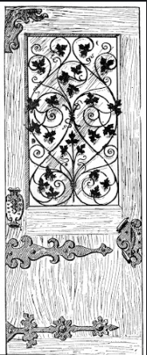

Toby Gray
Year 6
West Park Primary School
His piercing eyes were shining while he took a shaky breath. Many emotions had escorted him to the door with many secrets. Then, echoes from the depths sent an adrenaline-filled message to his overflowing mind. Fred finally felt alive. There he was at the hidden world. He eagerly swung the door open.
A gravitational pull has brought him back to his youth with force. In the very moment the door had swung behind him, his life was drawn to his delirious childhood memories. As Fred stepped forward, he stepped back into the early chapters of his life.
As the stories replayed in his mind, there were monkeys dominating the canopy of the forest, dominating like tyrant kings ruling their domain. There were huge boulders laying silently, meanwhile a soft green blanket of leaves overtook the ashen path. The viridescent canopy looked like a crowd of vivid green umbrellas. The interwoven ceiling of think branches shut out the sky and covered the path in darkness.
After taking in his surroundings, he strolled around looking at his fascinations. Upon his ears fell the music of the rainforest: the noise of monkeys, the shriek of parrots; the deadly chase of a jaguar. The sheer denseness of the foliage overtook his senses as he walked over the tacky ground, weaving in and out of trees. Fred noticed the verdant sky specked with cracks of sunlight, which seemed endless, endless because that was the only thing in his view.
Every part of the forest held a story from Fred’s early life. He saw a familiar thatched deck of wood and then remembered the raft he had made around twenty years ago. Fred couldn’t believe that for a period of time he had lived in that exact forest. Why had no one discovered this lush greenery before him? But then he remembered that Lila, Max and Con had explored this beauty with him. Which memory of this place had begged him to come back?
Glorious choruses of birds lifted the rainforest into the vibrant day. Monkeys leaped, vine to vine, only momentarily stopping to grab some fruit off the lofty gnarled trees. Shining and penetrating, blinding and hot the sun was rising like a glorious explosion of yellow and crimson. The forest was a beautiful myriad of life; colours were popping from every direction appearing into his view like flashes of a camera.
Fred wished that he could find Lila, Max and Con so they could re-live this moment together. As he turned the corner, there was a keen sense of homecoming as the door appeared in front of him. Relief had hit, yet sadness as well; sadness overtook every emotion he ever felt. It was time, time to open the creaking door. Fred hoped to come back next with Lila, Max and Con. Finally, he stepped forwards through the door, which took him back to reality.

